Opiniano, Ezkylle 02/24/2026
NW – 301 6BLOCKTECH
Finals Lab Activity 1: Coding and Testing ERC 721

Part 1 — Setup: MetaMask Sepolia + Test ETH
Task 1.1: Enable Sepolia in MetaMask
- Open MetaMask.
- Go to Settings → Advanced.
- Turn ON Show test networks.
- Open the network dropdown and select Sepolia.
Checkpoint: MetaMask network shows Sepolia.
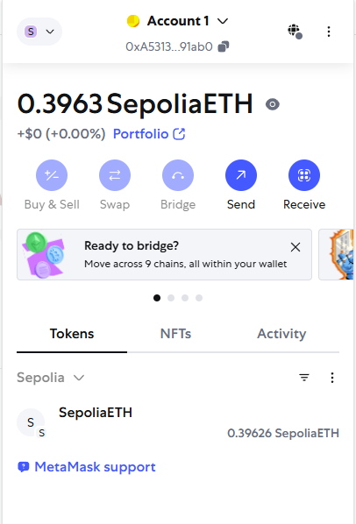

Task 1.2: Get Sepolia ETH from a Faucet
Use any faucet you prefer. Two common options:
- MetaMask testnet faucet
- Chainlink Sepolia faucet
- Copy your MetaMask wallet address.
- Request test ETH from the faucet.
- Wait until the balance updates.
Checkpoint: You have at least 0.2 Sepolia ETH (enough for deploy + multiple mint tests).


Part 2 — Remix Setup: Create the Contract File
Task 2.1: Open Remix and Create a File
- Go to remix.ethereum.org
- In File Explorer, click New File
- Name it:
FinalsLabERC721.sol
- Paste the contract code (exactly as given).
Checkpoint: File saved and visible in the explorer.

Part 3 — Dependencies: OpenZeppelin Imports
Task 3.1: Resolve OpenZeppelin Imports
Your contract uses:
- Ownable.sol
- ERC721URIStorage.sol
- Click Solidity Compiler tab.
- Click Compile once.
- If you see import errors (OpenZeppelin not found):
  - Go to File Explorer
  - Look for Dependencies / Remix Packages
  - Add/install OpenZeppelin Contracts
Checkpoint: The contract compiles without import errors.

Part 4 — Compile the Contract
Task 4.1: Compile Settings
- In Solidity Compiler:
  - Set compiler version to a 0.8.x version (example: 0.8.20+)
  - Ensure it matches pragma solidity ^0.8.0;
- Click: Compile SimpleMintContract.sol
Checkpoint: “Compilation successful” appears and no red errors show.
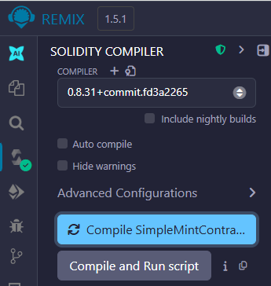

Part 5 — Connect Remix to MetaMask (Injected Provider)
Task 5.1: Use Injected Provider
- Go to Deploy & Run Transactions
- Under Environment, select:
  - Injected Provider – MetaMask (or “Injected Web3” depending on UI)
- MetaMask will pop up:
  - Approve connection
- Confirm MetaMask is still on Sepolia
Checkpoint: Remix shows your MetaMask address under “Account”.
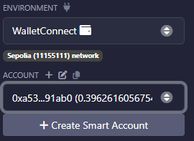

Part 6 — Deploy the ERC-721 Contract
Task 6.1: Deploy
- In Remix Deploy section:
  - Contract: SimpleMintContract
- Click Deploy
- MetaMask pops up → Confirm
Checkpoint: Contract appears under Deployed Contracts in Remix.
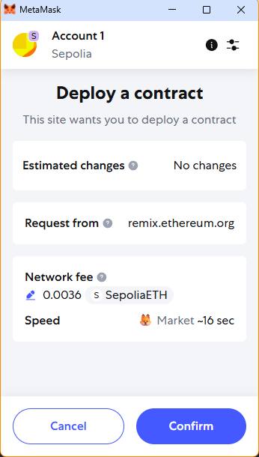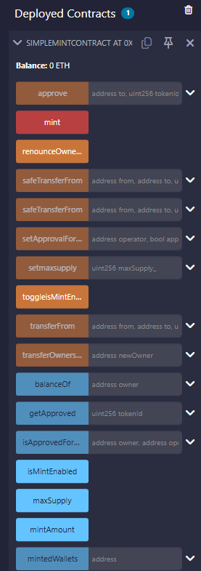

Task 6.2: Validate Initial Contract State (Read Calls)
In Deployed Contracts, click these read functions:
Function | Expected Value
owner() | your MetaMask address
isMintEnabled() | false
maxSupply() | 2
totalSupply() | 0
mintAmount() | 50000000000000000 wei (0.05 ETH)
Checkpoint: All values match.
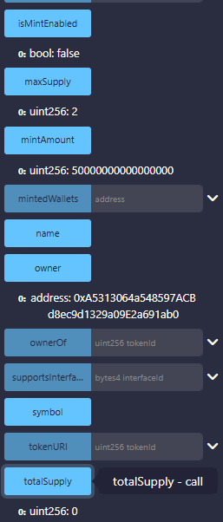

Part 7 — Functional Test Cases (Minting Rules)
Test Case 1 — Mint while Disabled (Should Fail)
Task 7.1: Attempt Mint (Expect Revert)
- Expand mint()
- In Remix top bar, set:
  - Value: 0.05
  - Unit: ether
- Click mint()
- Confirm transaction if MetaMask asks (it may fail before prompting depending on UI)
Expected Result: Transaction fails with:
- "Minting not enabled"
Record: Write the revert message in your lab notes.
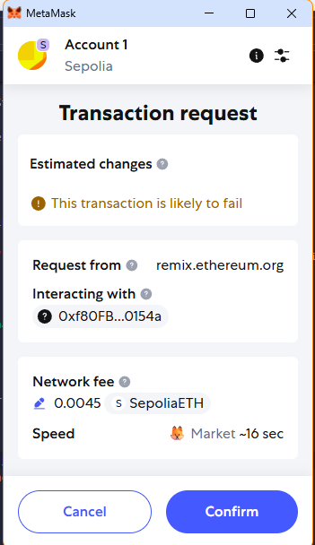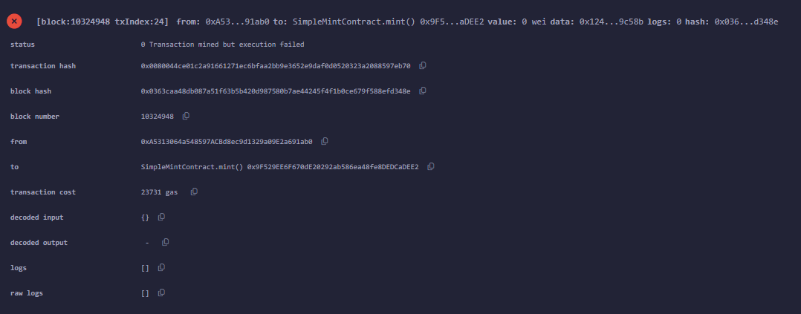

Test Case 2 — Enable Minting (Owner Only)
Task 7.2: Toggle Minting
- Click toggleisMintEnabled()
- Confirm in MetaMask
- Call isMintEnabled() again
Expected Result:
- isMintEnabled() → true
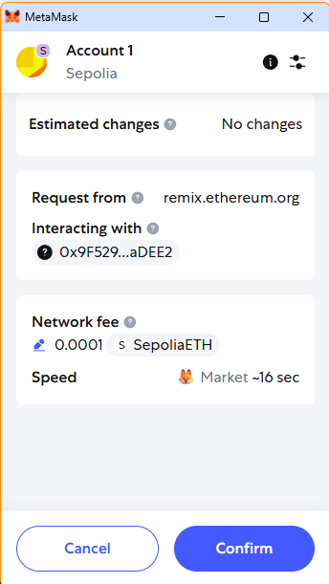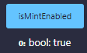

Test Case 3 — Successful Mint (Correct Payment)
Task 7.3: Mint First NFT
- Set Value = 0.05 ether
- Click mint()
- Confirm MetaMask
Expected Result (after mined):
- totalSupply() → 1
- mintedWallets(yourAddress) → 1
Record: Transaction hash + updated values.
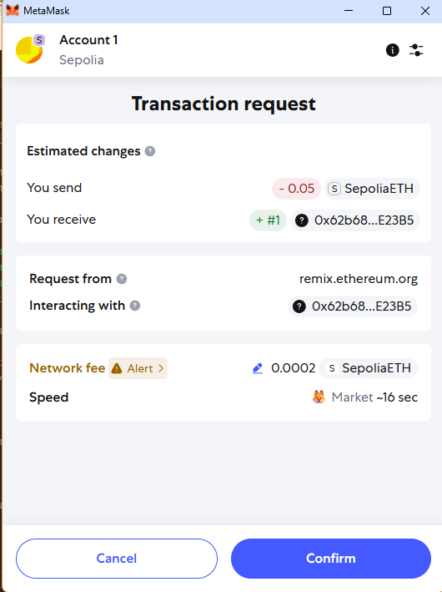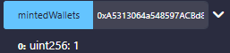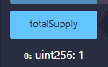

Test Case 4 — Mint Again Same Wallet (Should Fail)
Task 7.4: Attempt 2nd Mint from Same Wallet
- Set Value = 0.05 ether
- Click mint()
Expected Result: Revert message: "Exceeds max per wallet"
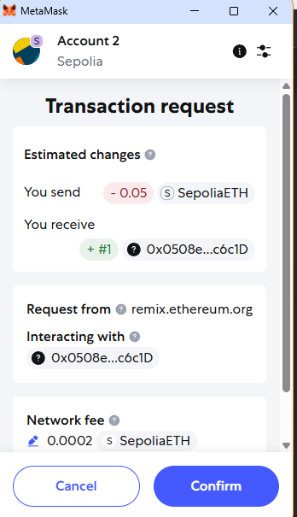

Test Case 5 — Max Supply Behavior (Need 2nd Wallet)
Because:
- maxSupply = 2
- each wallet can only mint 1

Task 7.5: Mint Using Another MetaMask Account
- In MetaMask, switch to Account 2
- Ensure Account 2 has Sepolia ETH
- Go back to Remix (Injected Provider automatically uses active account)
- Call mint() with 0.05 ether
Expected Result: totalSupply() → 2

Test Case 6 — Sold Out (Should Fail)
Task 7.6: Attempt Another Mint (Any Wallet)
Try minting again with any account.
Expected Result: Revert message: "Sold out"

Part 8 — Common Gotchas (Troubleshooting Checklist)
Issue A: Wrong Network
Symptom: Transactions fail / contract not visible / wrong chain
- Fix: Ensure MetaMask network is Sepolia
- Reminder: Injected Provider follows MetaMask network
Issue B: Wrong Value Sent
Symptom: Revert “Wrong value”
- Fix: Your contract requires:
  - msg.value == mintAmount exactly
- Use 0.05 ether or 50000000000000000 wei
Issue C: ERC721URIStorage “Unused”
Observation: You imported URI storage but did not set token URIs.
- Result: You can mint NFTs, but they won’t have metadata URIs unless you implement _setTokenURI.

Part 9 — Post-Lab Questions (Assessment)
Answer briefly:
- Why did mint() fail before enabling minting?
- What specific line enforces “1 mint per wallet”?
- What happens if you send 0.051 ETH?
- Why do you need a second wallet to reach maxSupply = 2?
- What is the value of mintAmount in wei?

Part 10 — Optional Extension (Metadata Upgrade Challenge)
Challenge Goal
Upgrade the contract so each minted token has a metadata URI.
Suggested approach
- Modify mint() to accept a URI:
  - mint(string memory uri) external payable
- After _safeMint, call:
  - _setTokenURI(tokenId, uri);
Success criteria:
- After minting, calling tokenURI(tokenId) returns the URI you provided.

Student Output Checklist (What to Submit)
Screenshots of the following:

  - MetaMask showing Sepolia network + balance
  - Remix deployed contract
  - Successful mint transaction (1st wallet)
  - Revert: “Minting not enabled”
  - Revert: “Exceeds max per wallet”
  - Successful mint transaction (2nd wallet)
  - Revert: “Sold out”

